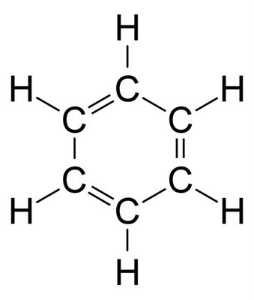CHEMISTRY 11

**Contact Info**

* [**jeannette.gobolos@sd27.bc.ca**](mailto:jeannette.gobolos@sd27.bc.ca)
* **250-392-6284**

GOBOLOS

2025-2026

**Chemistry 11**

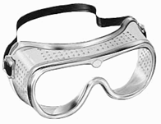**Chemistry 11 provides the framework for the scientific literacy of citizens, for the development of a highly skilled workforce, and for the development of technology.**

**In Chemistry 11 the following BIG IDEAS will be covered:**

1. **Atoms and Molecules** are building blocks of matter.

2. **Organic Chemistry** and its applications have significant implications for human health, society, and the environment.

3. The **MOLE** is a quantity used to make atoms and molecules more measurable.

4. Matter and Energy are conserved in **CHEMICAL REACTIONS.**

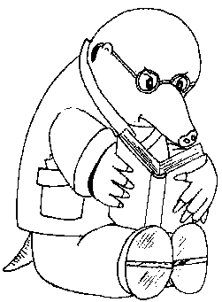5. **SOLUBILITY** within a solution is determined by the nature of the solute and solvent**.**

[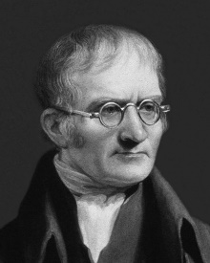](https://www.google.ca/url?sa=i&rct=j&q=&esrc=s&source=images&cd=&cad=rja&uact=8&ved=2ahUKEwiQ_vj45fTbAhXSLX0KHX3hB2wQjRx6BAgBEAU&url=https%3A%2F%2Falchetron.com%2FJohn-Dalton&psig=AOvVaw2MmODBQ52RkeSfZu9s5TRD&ust=1530221617385136)[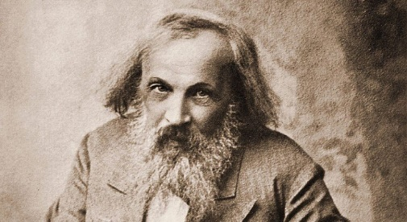](http://www.google.ca/url?sa=i&rct=j&q=&esrc=s&source=images&cd=&cad=rja&uact=8&ved=2ahUKEwiokrmL5fTbAhWrFjQIHV_ADhsQjRx6BAgBEAU&url=http%3A%2F%2Fwww.dmitrimendeleev.com%2F&psig=AOvVaw3E2ATx8cO7GjtHUqHbsCJv&ust=1530221393895206)

[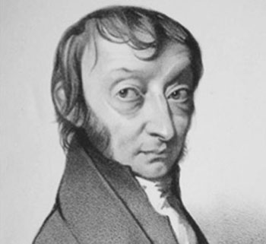](https://www.google.ca/url?sa=i&rct=j&q=&esrc=s&source=images&cd=&cad=rja&uact=8&ved=2ahUKEwjt2tWp5fTbAhUYFTQIHeHTCBwQjRx6BAgBEAU&url=https%3A%2F%2Fwww.learner.org%2Fcourses%2Fchemistry%2Ftext%2Ftext.html%3Fdis%3DU%26num%3DYm5WdElUQS9OeW89%26sec%3DYzJWaklUQS9NeW89&psig=AOvVaw1NPngCx-67laF42m0O-oOT&ust=1530221438361561)

**Students are expected to be able to do the following …**

* question and predict
* plan and conduct
* [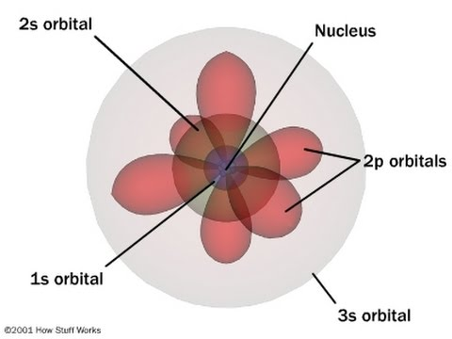](https://www.google.ca/url?sa=i&rct=j&q=&esrc=s&source=images&cd=&cad=rja&uact=8&ved=2ahUKEwi_u-uq5vTbAhX8HTQIHeapARgQjRx6BAgBEAU&url=https%3A%2F%2Fwww.youtube.com%2Fwatch%3Fv%3DEU8-ZS8C-0E&psig=AOvVaw3LZm3rXkAyQeT8BjxifHqB&ust=1530221708929025)process and analyze data and information
* evaluate
* apply and innovate
* communicate

[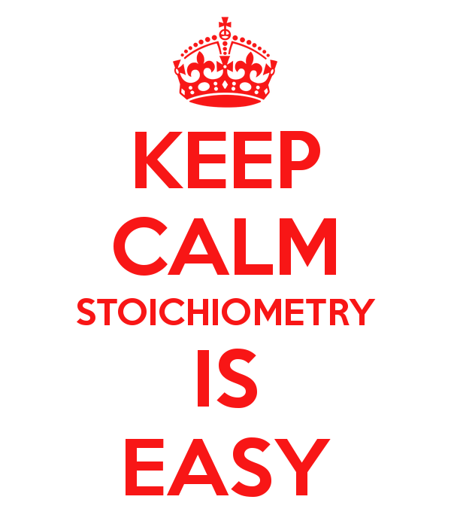](https://www.google.ca/url?sa=i&rct=j&q=&esrc=s&source=images&cd=&cad=rja&uact=8&ved=2ahUKEwjmgtPa5vTbAhVDM30KHWl5DiYQjRx6BAgBEAU&url=https%3A%2F%2Fvillanovachemistry.wordpress.com%2F2017%2F06%2F02%2Fstoichiometry%2F&psig=AOvVaw3GzcWmzI_mJcGV5L-NA8Ee&ust=1530221815070119)

**Students are expected to know the following …**

* quantum mechanical model and electron configuration
* valence electrons and Lewis structures
* chemical bonding based on electronegativity
* bonds / forces
* organic compounds
* applications of organic chemistry
* 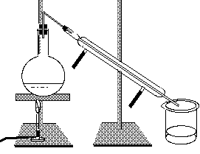dimensional analysis
* reactions
* stoichiometric calculations using significant figures
* local and other chemical processes
* green chemistry
* solubility of molecular and ionic compounds
* analysis techniques

[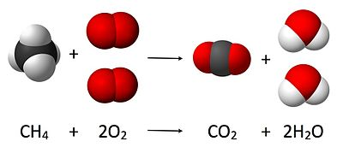](https://www.google.ca/url?sa=i&rct=j&q=&esrc=s&source=images&cd=&cad=rja&uact=8&ved=2ahUKEwiFqO2-5_TbAhVsIjQIHdN6A1YQjRx6BAgBEAU&url=https%3A%2F%2Fen.wikipedia.org%2Fwiki%2FStoichiometry&psig=AOvVaw3GzcWmzI_mJcGV5L-NA8Ee&ust=1530221815070119)

**[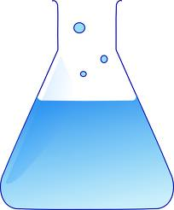](http://www.google.ca/imgres?q=chemistry+equipment&hl=en&biw=1600&bih=719&tbm=isch&tbnid=COMBRuL8JRjPQM:&imgrefurl=http://www.glogster.com/rla/cv-radek-lasak-9/g-6lnoj3r1972ou4cgtnav8a0&docid=dBNnI_uo59gOQM&imgurl=http://8fb80e.medialib.glogster.com/media/49912e86cdac82d71bc722958489378fab4aae872e06298eb49ae097412dcd54/cartoon-chemistry-equipment-i1.png&w=498&h=600&ei=0cLIUbvEJ-H2igLqkIDoDg&zoom=1&iact=hc&vpx=746&vpy=192&dur=7235&hovh=246&hovw=204&tx=99&ty=173&page=2&tbnh=137&tbnw=114&start=39&ndsp=46&ved=1t:429,r:52,s:0,i:317)Evaluation**

**Final Mark**

* Terms - 40% each
* Final Exam - 20%

**Term Mark**

* 40% assignments, labs, and activities
* 60% quizzes and tests

[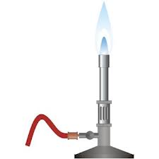](http://www.google.ca/imgres?q=bunsen+burner&hl=en&biw=1600&bih=719&tbm=isch&tbnid=KTGaN5-_Hy4ylM:&imgrefurl=http://glossary.periodni.com/glossary.php?en%3DBunsen%2Bburner&docid=fSzYVbC8TW1ZqM&imgurl=http://glossary.periodni.com/images/bunsen_burner.jpg&w=350&h=350&ei=asPIUa2lMOPSiwKmwoDYAg&zoom=1&iact=hc&vpx=87&vpy=159&dur=709&hovh=225&hovw=225&tx=146&ty=130&page=1&tbnh=143&tbnw=143&start=0&ndsp=43&ved=1t:429,r:33,s:0,i:247)**Classroom Expectations and Procedures**

**1. You will be expected to:**

* **adhere to all CoVid-19 protocols as established by LCSS, the Ministry of Education, and the BC Provincial Health Officer**
* obey all school rules
* attend all classes
* arrive to class on time
* bring necessary materials to class (pen, pencil, calculator, periodic table, etc.)
* keep the classroom tidy
* keep your cell phone out of sight
* respect everyone in the classroom!
* work until dismissed by Ms. Gobolos

**2. The procedures you must follow are:**

**a. Absence**

**Chemistry 11 is an academic course. Regular attendance is incredibly important. However, if you are sick, please follow the protocols in place.**

* it is the responsibility of the student to catch up on all work missed!
* **if you are absent, please e-mail me and I will attempt to send you an electronic copy of the notes/assignment**
* **be present on TEST days (a phone call or e-mail is needed if a test is to be missed)**

**b. Late**

* enter the classroom quietly and begin working

**c. Assignments**

* assignments must be handed in on time to receive full marks
* you will lose 10% per day for any late assignments (up to 50%)

**d. Washroom**

* use at the appropriate time
* must ask permission before leaving the classroom

**If inclement weather (cancellation of school buses) causes the suspension of in-class instruction, please visit the following website, “Science and Scholarships with Ms. Gobolos”. If there are any assignments for the day, they will be posted under the Chemistry 11 tab.**



**https://jeannettegobolos.wixsite.com/jeannette-gobolos**