[](https://www.google.ca/url?sa=i&rct=j&q=&esrc=s&source=images&cd=&cad=rja&uact=8&ved=2ahUKEwi4rf3_x_TbAhUlL30KHfJ1BFYQjRx6BAgBEAU&url=https%3A%2F%2Fwww.fotolia.com%2Fp%2F203993955&psig=AOvVaw0LIg4gV-Lj9Sw5ye56zBxr&ust=1530213561626979)**CHEMISTRY 12 2025 - 2026**

**GOBOLOS**

**Chemistry 12**

**Chemistry 12 provides a foundation for the scientific literacy of citizens, for the development of a highly skilled work force, and for the development of technology.**

**In Chemistry 12 the following BIG IDEAS will be covered …**

1. Reactants must collide to react, and the **reaction rate** is dependent on the surrounding conditions.

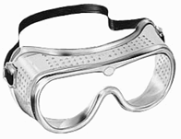

1. **Dynamic equilibrium** can be shifted by changes to the surrounding conditions.
2. **Saturated solutions** are systems in equilibrium.
3. **Acid or base strength** depends on the degree of ionization (dissociation).
4. **Oxidation and reduction** are complementary processes that involve the loss or gain of electrons.

[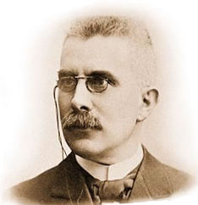](https://www.google.ca/url?sa=i&rct=j&q=&esrc=s&source=images&cd=&cad=rja&uact=8&ved=2ahUKEwjc2uaLxPTbAhW6CDQIHYNSAVEQjRx6BAgBEAU&url=https%3A%2F%2Fen.wikipedia.org%2Fwiki%2FHenry_Louis_Le_Chatelier&psig=AOvVaw2lgLZF1Bo-by5b-gw1HlVc&ust=1530212498021577)**Students are expected to be able to do the following …**

* question and predict
* plan and conduct
* process and analyze data and information
* evaluate
* apply and innovate
* communicate

[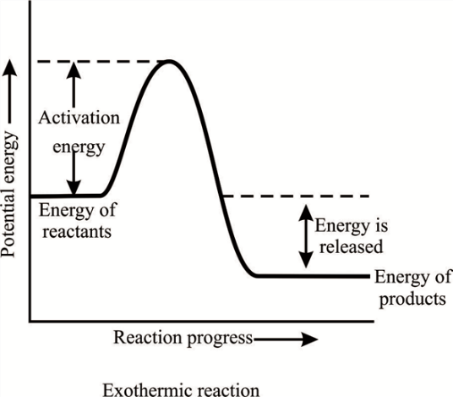](https://www.google.ca/url?sa=i&rct=j&q=&esrc=s&source=images&cd=&cad=rja&uact=8&ved=2ahUKEwiU2Iqjx_TbAhX_IjQIHZpkDDMQjRx6BAgBEAU&url=https%3A%2F%2Fwww.chegg.com%2Fhomework-help%2Fexothermic-reactions-usually-self-sustaining-following-expla-chapter-10.1-problem-3tsh-solution-9780132885485-exc&psig=AOvVaw05MNt-EoZA18lumLrlKPwc&ust=1530213378925813)

**Students are expected to know the following …**

* reaction rate
* collision theory
* energy change during a chemical reaction
* reaction mechanism
* catalysts
* dynamic nature of chemical equilibrium
* Le Chatelier’s Principle and equilibrium shift
* Keq – equilibrium constant
* saturated solutions and solubility product constant (Ksp)
* relative strength of acids and bases in solution
* water as an equilibrium system
* [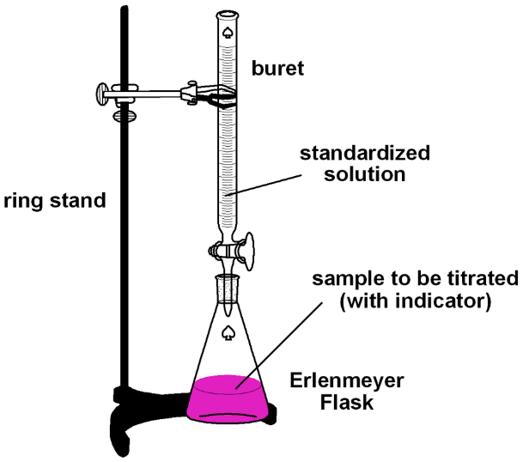](http://www.google.ca/url?sa=i&rct=j&q=&esrc=s&source=images&cd=&cad=rja&uact=8&ved=2ahUKEwj1n5bSxPTbAhXIGTQIHVlmAhsQjRx6BAgBEAU&url=http%3A%2F%2Fsachiacidbase.weebly.com%2Ftitrations.html&psig=AOvVaw1kqe9ASyiXbJ89ERtBwTgS&ust=1530212677038173)weak acids and weak bases
* titration
* hydrolysis of ions in salt solutions
* applications of acid-base reactions
* oxidation – reduction process
* electrochemical cells
* electrolytic cells
* quantitative relationships

[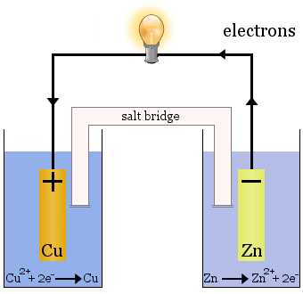](https://www.google.ca/url?sa=i&rct=j&q=&esrc=s&source=images&cd=&cad=rja&uact=8&ved=2ahUKEwir_fOyxPTbAhUTO30KHUR-CjcQjRx6BAgBEAU&url=https%3A%2F%2Fwww.chemicool.com%2Fdefinition%2Felectrochemical-cell.html&psig=AOvVaw0ez5U8WVaAccds9Rf_jK8r&ust=1530212601711101)

**Contact Info**

* [**jeannette.gobolos@sd27.bc.ca**](mailto:jeannette.gobolos@sd27.bc.ca)
* **250-392-6284 (LCSS)**

**Evaluation**

**Chemistry 12 is an academic course. Regular attendance is incredibly important. However, if you are sick, please follow the protocols in place.**

**Term Mark** 40% assignments, labs, and activities

60% quizzes, tests, and exams

**Final Mark** 40% for each term (80% total)

20% Final Exam

**Classroom Expectations and Procedures**

**You will be expected to …**

* **adhere to all CoVid-19 protocols as established by LCSS, the Ministry of Education, and the BC Provincial Health Officer**
* obey all school rules
* attend all classes
* arrive to class on time
* bring necessary materials to class (pen, pencil, calculator, data booklet, periodic table, etc.)
* keep the classroom tidy
* keep your cell phone out of sight
* work until dismissed by Ms. Gobolos
* **RESPECT EVERYONE IN THE CLASSROOM!**

**The procedures you must follow are …**

**1. Absence**

* it is the responsibility of the student to catch up on all work missed!
* **If you are absent, please e-mail me and I will attempt to send you an electronic copy of the notes/assignment**
* be present on TEST days (a phone call or e-mail from a parent is required if a test is to be missed)

**2. Late**

* enter the classroom quietly and begin working

**3. Assignments**

* assignments must be handed in on time to receive full marks
* 10% will be deducted each day an assignment is late (up to 50%)

**4. Washroom**

* use at the appropriate time
* must ask my permission before leaving the classroom

**In the event that inclement weather (cancellation of school buses) causes the suspension of in-class instruction, please visit the following website … “Science and Scholarships with Ms. Gobolos”.**



**https://jeannettegobolos.wixsite.com/jeannette-gobolos**